End-to-End Customer Purchase
&
Behaviour Analytics Report

- By Aayush Kumbhar
Data Analyst

Tools Used: Python, MySQL, Power BI, Excel
Date: 24/12/2025 – 31/12/2025

Executive Summary
This project presents an end-to-end data analytics workflow aimed at transforming raw customer shopping data into meaningful business insights using industry-standard tools. The dataset consists of approximately 3,900 records and 19 columns, representing customer demographics, purchasing behaviour, and transactional details.
The analysis began with data cleaning and feature engineering using Python (Pandas). Raw data contained fewer columns initially; additional features were created to enhance analysis, improve data quality, and support meaningful business metrics. This step ensured consistency, handled missing or inconsistent values, and prepared the dataset for reliable analysis.
Following data preparation, MySQL Workbench was used to perform structured data analysis and aggregations. SQL queries were written to explore trends, calculate key metrics, and segment data across relevant dimensions such as customer behaviour and purchasing patterns. This step enabled efficient analysis of large datasets and supported KPI-level insights.
Finally, Power BI was used to design an interactive dashboard that visualises key performance indicators and trends. The dashboard allows stakeholders to quickly understand business performance, compare metrics across segments, and identify patterns that support data-driven decision-making.
Overall, this project demonstrates the ability to handle the complete analytics lifecycle from raw data to actionable insights using Python, SQL, and Power BI. The outcome is a decision-support-ready analysis that highlights customer behaviour patterns and business performance in a clear, intuitive, and stakeholder-friendly manner.

Business Problem & Objectives
Business Problem
The business has customer shopping data available, but it is mostly in raw form and not easily understandable. As a result, it is challenging to clearly understand how customers are shopping, how much they are spending, and which factors are influencing overall business performance.
Even though transaction data exists, it is not properly analysed or visualised, which makes it hard for stakeholders to:
- Understand which types of customers contribute more to sales.
- See how customer purchasing behaviour differs across transactions.
- Identify basic trends or patterns that could help in decision-making.
As a result, important insights remain hidden in the data, and decisions are often made without clear data support.

Objectives of the Analysis
The main objective of this project is to study customer shopping behaviour and turn raw data into useful insights that can support business decisions.
The analysis focuses on:
- Understanding the overall purchasing behaviour of customers
- Identifying important metrics related to business performance
- Analysing customer behaviour across different categories and segments
- Creating an interactive dashboard that is easy to understand
- Helping users quickly track performance and observe trends
By completing this analysis, the project provides a clear and structured view of customer shopping patterns, which can help stakeholders better understand the data and make more informed decisions.

Data Overview
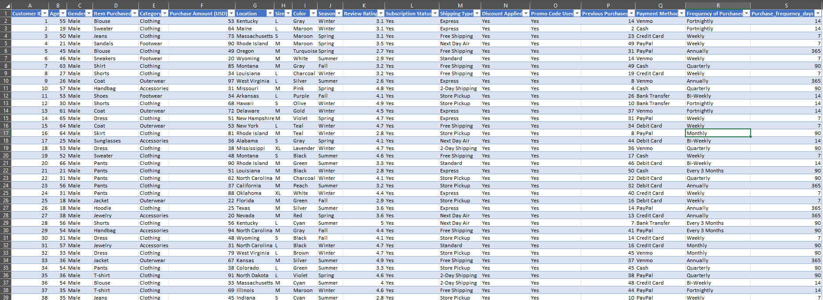
Dataset (Excel):

Data source and information
The dataset used for this project is an Excel-based customer shopping dataset. A snapshot of the data is shown above to understand the structure and available fields. After preprocessing, the dataset contains around 3,900 rows and 19 columns.

Data Overview
The dataset contains information about customers and their order purchase behaviour. It captures details such as what customers ordered, whether they purchased a company subscription, and the location of orders across the United States.
The data also includes information on seasonal purchasing patterns and the time gap between customer orders, which helps in understanding how frequently customers return to make purchases.
In addition, the dataset records the number of previous purchases made by each customer. This makes it possible to distinguish between new customers and returning customers.
Lastly, the dataset includes product review ratings, which provide insight into customer feedback and satisfaction levels.

Data Cleaning & Feature Engineering (Python – Pandas)

During initial data inspection, 37 missing values were found in the review_rating column. These missing values were handled by replacing them with the median review rating within each product category, ensuring more meaningful and accurate values.
To improve analysis, additional columns were created:
- Age Group, where customer ages were categorised into Young Adult, Adult, Middle Age, and Senior
- Purchase Frequency (Days), where purchase frequency values were converted into numerical day values (for example, weekly = 7 days)
It was also observed that the discount_applied and promo_code_used columns contained identical information. To remove redundancy, the promo_code_used column was dropped.
After these steps, the dataset was clean and ready for SQL analysis and Power BI visualisation.
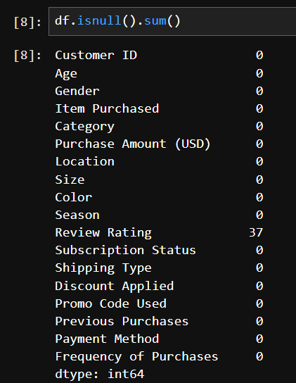
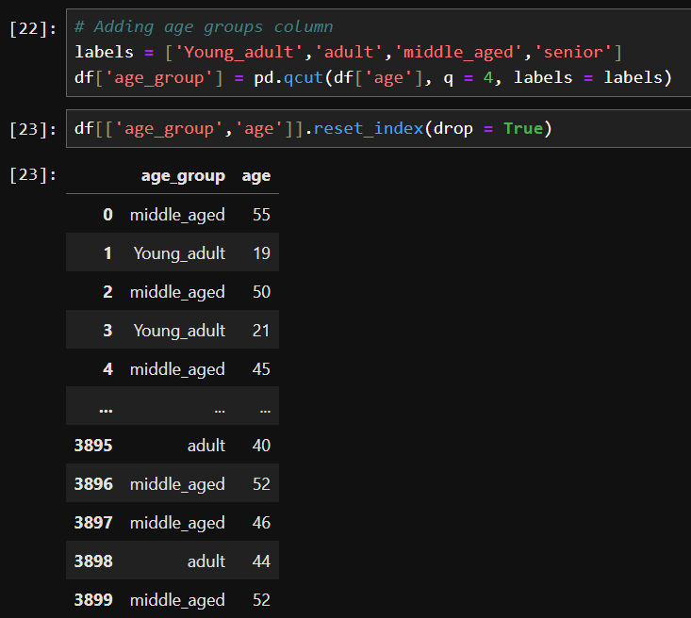

SQL Analysis & Aggregations
After data cleaning and feature engineering, the dataset was analyzed using MySQL Workbench to answer detailed business questions related to customer behavior, revenue drivers, discounts, subscriptions, product performance, and regional trends.
SQL was primarily used for aggregation, segmentation, and comparative analysis.

1. Customer Spending & Revenue Analysis
The analysis focused on understanding how revenue is distributed across different customer groups:
- Compared total revenue generated by male vs female customers
- Calculated average purchase amount (AOV) and total revenue for subscribed and non-subscribed customers
- Evaluated revenue contribution by age group
- Identified locations with the highest and lowest average revenue per customer
- Analyzed payment methods preferred by high-value customers (customers spending above average)
This helped identify high-value customer segments and regions contributing most to overall revenue.

2. Subscription & Retention Analysis
Subscription behavior was analyzed in detail to understand its impact on revenue and customer value:
- Compared average spend and total revenue between subscribers and non-subscribers
- Calculated the percentage of subscribed customers out of the total customer base
- Analyzed subscription distribution by gender
- Studied whether repeat buyers (more than 5 previous purchases) are more likely to subscribe
- Calculated customer retention rate based on purchase frequency and long gaps between purchases
This analysis highlighted gaps in subscription adoption and retention opportunities.

3. Discount & Pricing Analysis
Discount effectiveness was evaluated to understand customer response and pricing impact:
- Identified customers who used discounts but still spent more than the average purchase amount
- Compared total purchases and revenue between discounted and non-discounted orders
- Identified products with the highest and lowest percentage of discounted purchases
- Analyzed season-wise performance of discounted products, including items that performed poorly even when discounts were applied
This helped assess whether discounts are driving value or simply reducing margins.

4. Product Performance Analysis
Product-level analysis was performed to understand demand and customer preference:
- Identified the top 5 products with the highest average review ratings
- Analyzed the top 3 most purchased products within each category
- Identified product categories with high purchase frequency but low average spend
- Studied product preferences among specific customer segments such as adults and seniors
This provided clarity on both high-performing and underperforming products.

5. Customer Segmentation & Purchase Behaviour
Customers were segmented to better understand purchasing patterns:
- Segmented customers into New, Returning, and Loyal based on previous purchase counts
- Calculated the number of customers in each segment
- Analyzed purchase frequency gaps, including customers with long intervals between purchases
- Studied purchase behavior by season, including average spend, number of purchases, and total revenue per season
This helped identify engagement patterns and reactivation opportunities.

6. Regional & Location-Based Analysis
Geographic analysis was conducted to evaluate regional performance:
- Calculated average revenue per customer by location
- Identified low-performing regions based on customer value
- Analyzed top purchased products within low-performing locations
This analysis supports location-specific marketing and promotional strategies.

Outcome
The SQL analysis transformed raw transactional data into meaningful, summarized insights across customers, products, pricing, subscriptions, and locations. These aggregated results were then used to define KPIs and build interactive visualizations in Power BI, ensuring the dashboard focused only on the most impactful insights.

KPI Definitions
The following key performance indicators (KPIs) were used in the dashboard to track customer behaviour and overall business performance:
- Total Customers (3,900)
Represents the total number of unique customers included in the analysis.
- Total Revenue ($233K)
Shows the total revenue generated from all customer purchases.
- Average Order Value (AOV – $59.76)
Indicates the average amount spent per order, helping to understand customer spending behaviour.
- Revenue per Customer ($59.8)
Measures the average revenue generated from each customer, useful for evaluating customer value.
- Repeat Customer Rate (97.87%)
Represents the percentage of customers who have made more than one purchase, indicating strong customer retention.
- Average Review Rating (3.75)
Reflects overall customer satisfaction based on product review ratings.

Supporting Performance Indicators (Used in Visuals)
In addition to the main KPIs, the dashboard also highlights supporting metrics through visual analysis:
- Revenue Contribution by Gender
Shows how total revenue is split between male and female customers.
- Age-wise Revenue Contribution
Displays revenue generated by different age groups to identify high-value customer segments.
- Revenue with Discount vs Without Discount
Compares revenue generated from discounted and non-discounted purchases to assess the impact of discounts.
- Category-wise Number of Purchases
Highlights which product categories drive the highest purchase volume.
- Payment Method Usage
Shows customer preference for different payment methods based on purchase activity.

Why were these KPIs selected
These KPIs were chosen to provide a clear view of revenue performance, customer value, retention, and satisfaction. Together, they help stakeholders quickly understand how the business is performing and identify key customer segments driving revenue.

Dashboard Overview
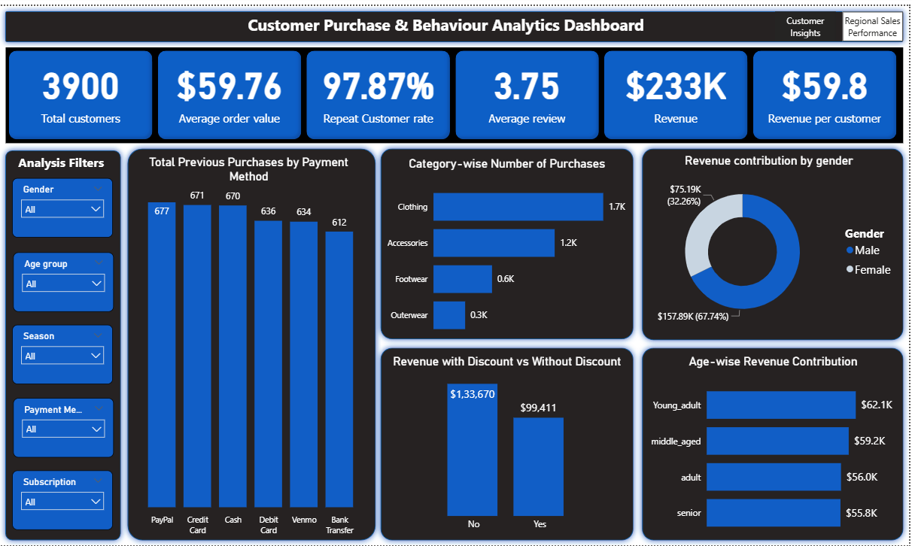
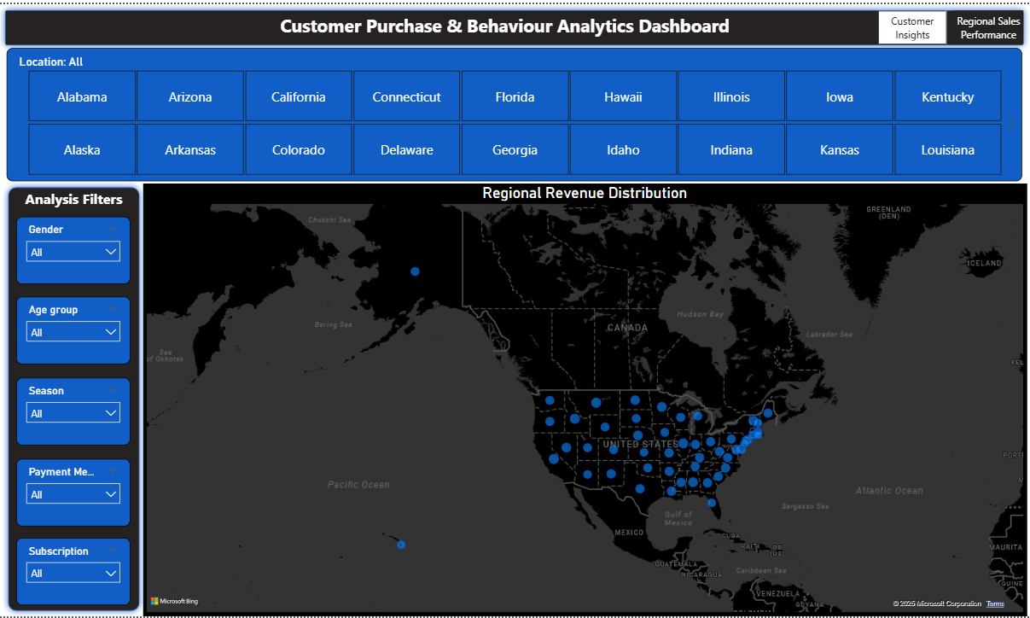

The Customer Purchase & Behaviour Analytics Dashboard was built in Power BI to provide an interactive view of customer purchasing patterns, revenue performance, and regional trends. The dashboard is designed to help users quickly explore the data and identify key patterns using filters and visual summaries.
Dashboard Structure
The dashboard is divided into two main views:
- Customer Insights
- Regional Sales Performance
Users can switch between these views to analyse customer behaviour at both an overall and location-based level.

Key KPI Section (Top Panel)
At the top of the dashboard, key business metrics are displayed for quick performance tracking:
- Total Customers
- Total Revenue
- Average Order Value
- Revenue per Customer
- Repeat Customer Rate
- Average Review Rating
These KPIs provide an instant snapshot of overall business performance and customer behaviour.

Customer Behaviour & Revenue Analysis
The main visuals in the dashboard focus on understanding how customers purchase and contribute to revenue:
- Category-wise Number of Purchases
Shows which product categories have the highest purchase volume.
- Revenue Contribution by Gender
Highlights how revenue is split between male and female customers.
- Age-wise Revenue Contribution
Displays revenue generated by different age groups to identify high-value customer segments.
- Revenue with Discount vs Without Discount
Compares revenue from discounted and non-discounted purchases to evaluate discount impact.
- Previous Purchases by Payment Method
Shows customer purchase history across different payment methods.

Regional Sales Performance
The regional view displays a map of the United States showing revenue distribution across different locations. This helps users identify:
- High-revenue regions
- Geographic concentration of customer activity
State-level selection buttons allow users to focus on specific locations for deeper analysis.

Filters & Interactivity
The dashboard includes interactive filters for:
- Gender
- Age Group
- Season
- Payment Method
- Subscription Status
- Location
These filters allow users to dynamically explore the data and compare performance across different customer segments and regions.

Purpose of the Dashboard
The dashboard is designed to:
- Provide a clear overview of customer purchasing behaviour
- Help stakeholders track revenue and customer value
- Support data-driven decisions related to marketing, pricing, and customer targeting
Key Insights from the Analysis
1. Revenue Contribution by Gender
Male customers generate more than double the total revenue compared to female customers. This indicates that male customers are currently the primary contributors to overall revenue.
Why it matters:
There is a clear opportunity to improve revenue by increasing engagement and targeted offerings for female customers.

2. Product Ratings Indicate Moderate Customer Satisfaction
The overall average product rating is below 4, which suggests that customer satisfaction is moderate rather than strong. However, products such as Gloves, Sandals, Boots, Hats, and Skirts have the highest average ratings.
Why it matters:
Low average ratings can negatively impact repeat purchases. High-rated products can be promoted more, while low-rated products need quality or experience improvements.

3. Shipping Type Has Limited Impact on Spend
The most frequently used shipping options are Free Shipping, Standard Shipping, and Store Pickup. The average purchase amount across the top shipping types is very similar.
Why it matters:
Shipping type does not strongly influence how much customers spend, giving the business flexibility in logistics and shipping strategy.

4. Subscription Model Is Underperforming
There is no significant difference in average spend between subscribed and non-subscribed customers. However, non-subscribed customers contribute nearly 1.5 times more total revenue. Only 27% of customers are subscribed, and all subscribers are male.
Why it matters:
The subscription plan does not currently provide strong value to customers, especially female customers, and needs improvement to increase adoption and revenue impact.

5. Discount Impact Varies by Product
Some products such as Socks, Blouses, and Sandals show a low percentage of purchases even when discounts are applied. On the other hand, products like Sneakers, Hats, Coats, Sweaters, and Pants perform well with discounts.
Why it matters:
Discounts are not equally effective across all products. Certain products may need better visibility or bundling, while others do not require additional promotion.

6. Strong Customer Retention with Re-engagement Opportunity
The customer retention rate is high at around 86%, showing strong repeat purchase behavior. However, about 14% of customers place orders with a gap of one year between purchases.
Why it matters:
While retention is strong overall, customers with long gaps represent an opportunity for re-engagement through targeted campaigns and reminders.

7. Age Group Revenue Differences
Young customers contribute the highest share of revenue, while adults and seniors contribute the least. These groups mainly purchase items from the Clothing and Outerwear categories.
Why it matters:
Targeted offers such as combo deals could increase average spend among adult and senior customers.

8. Payment Method Patterns by Customer Value
High-value customers primarily use credit cards, cash, and debit cards, while lower-value customers show higher usage of PayPal and Venmo.
Why it matters:
Encouraging digital payment methods could improve transaction efficiency and cash flow management.

9. Seasonal Purchase Behaviour
Customer purchases are highest during the fall season and lowest during summer.
Why it matters:
There is potential to improve sales during summer through focused promotions and marketing campaigns.

10. Underperforming Product Categories
The Outerwear category shows both low purchase frequency and low average spend.
Why it matters:
This category may require better promotion, repositioning, or targeted advertising to improve performance.

11. Regional Performance Differences
Locations such as Wisconsin, Florida, Maryland, Kentucky, Delaware, Kansas, and Connecticut have lower average revenue per customer.
Why it matters:
Region-specific promotions like free delivery or first-order discounts could help improve performance in these areas.

Business Recommendations
Based on the insights derived from the analysis, the following business recommendations are proposed to improve customer engagement, revenue performance, and overall business outcomes:

1. Improve Engagement with Female Customers
Male customers currently contribute significantly more revenue than female customers.
Recommendation:
Design targeted marketing campaigns and personalised offers for female customers to increase their engagement and revenue contribution.

2. Address Product Rating Concerns
The overall average product rating is below 4, indicating moderate customer satisfaction.
Recommendation:
Customer reviews should be closely monitored, and low-rated products should be reviewed for quality or experience issues. Ignoring these ratings may negatively impact product performance and repeat purchases.

3. Review and Redesign the Subscription Model
Subscribed customers do not spend more on average than non-subscribed customers, and non-subscribers generate higher total revenue. Subscription adoption is low, and all subscribers are male.
Recommendation:
Revise the subscription plan to make it more attractive and balanced for customers of both genders. The benefits should be clearly communicated and aligned with customer needs to encourage higher adoption.

4. Optimise Discount Strategy by Product
Some products show low purchase activity even when discounts are applied, while others perform well with discounts.
Recommendation:
- Promote low-performing discounted products on the front page or through visibility-focused campaigns.
- Avoid unnecessary promotions for products that already perform well with discounts, as customers are already aware of these offers.

5. Re-engage Customers with Long Purchase Gaps
A notable portion of customers place orders with a gap of one year between purchases.
Recommendation:
Reach out to these customers through email or messaging campaigns, informing them about new discounts and offers based on their previous purchase categories to encourage repeat purchases.

6. Increase Revenue from Adult and Senior Customers
Adult and senior age groups contribute less revenue compared to younger customers and mainly purchase clothing and outerwear items.
Recommendation:
Introduce combo offers or bundled deals that encourage customers to purchase multiple products, helping increase average order value for these segments.

7. Improve Payment Method Efficiency
Cash is widely used by customers, including high-value customers.
Recommendation:
Encourage customers to use digital payment methods by introducing a small service fee for cash payments. The fee should be minimal to avoid customer drop-off, and the collected amount can help offset delivery partner costs.

8. Boost Sales During Low-Performing Seasons
Customer purchases are lowest during the summer season.
Recommendation:
Run targeted advertising and promotional campaigns during the summer to increase customer engagement and balance seasonal sales trends.

9. Improve Performance of Low-Value Product Categories
The outerwear category shows low purchase frequency and low average spend.
Recommendation:
Increase promotion of outerwear products through social media advertising or seasonal campaigns to improve visibility and sales.

10. Strengthen Performance in Low-Revenue Locations
Certain states show lower average revenue per customer.
Recommendation:
Introduce location-based promotions such as first-order discounts or free delivery to improve customer acquisition and spending in low-performing regions.

Conclusion & Limitations
Conclusion
This project demonstrates an end-to-end data analytics workflow, starting from raw customer shopping data and ending with actionable business insights. Using Python (Pandas) for data cleaning and feature engineering, MySQL for analysis and aggregation, and Power BI for visualisation, the project provides a clear understanding of customer behaviour, revenue drivers, and product performance.
The analysis identified key patterns related to customer segments, subscription behaviour, discount effectiveness, seasonal trends, and regional performance. These insights were translated into practical business recommendations aimed at improving customer engagement, revenue contribution, and overall decision-making.
Overall, the project shows how structured data analysis can support business decisions by converting raw data into meaningful insights through a combination of SQL analysis and interactive dashboards.

Limitations
While the analysis provides valuable insights, it has a few limitations:
- Customer behaviour was analysed based on historical data and does not account for external factors such as marketing campaigns or economic conditions.
- The analysis focuses on descriptive insights and does not include predictive modelling or forecasting.
- Some assumptions were made during data cleaning and feature engineering, which may slightly impact results.

